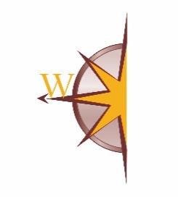

**WOTA – Western Oakland Transportation Authority**

**205 W. Livingston Rd., Highland, MI 48357**

SPECIAL BOARD MEETING – **ELECTRONICALLY HELD**

**Monday, May 18 at 9:00 am**

**AGENDA PRESENTER ACTION**

1. Call to Order
2. Pledge of Allegiance
3. Roll
4. Approval of Agenda
5. This special meeting is being called to:
   1. Review the recent contract agreement received from SMART on 5-11-2020 acknowledging WOTA as a combined entity formed through an interlocal agreement between Highland, Waterford and White Lake townships. The purpose of the SMART agreement is to authorize the transfer to WOTA of all vehicle lease agreements for vehicles currently under lease through said municipalities, and all Municipal Credits, Specialized Services Credits and 5310 FTA Grant reimbursement funds currently dispersed by SMART to said municipalities.
   2. Discuss potential options.
   3. Discuss the potential future with the City of Walled Lake since current transportation management contract with Highland expires 6-30-2020.
6. Board Member Commentary/Discussion
7. Next Meeting Date
   1. **TBD**
8. Adjournment